END-EFFECTOR COORDINATE SEARCH ON ARM MANIPULATOR 6 DOF WITH DENAVIT-HARTENBERG METHOD AND MASTER CONTROLLER

Fachri Maulana Fulchan 1[1], Setyawan Ajie Sukarno 1[2] and Susetyo Bagas Bhaskoro 1[3]

*1Department of Automation Engineering, Bandung Polytechnic of Manufacturing, Bandung, Indonesia*

[fachrimaulana40@gmail.com](mailto:fachrimaulana40@gmail.com), setyawanajies@gmail.com, [bagas@ae.polman-bandung.ac.id](mailto:bagas@ae.polman-bandung.ac.id)

Keywords: Arm Manipulator 6 Degree Of Freedom, Forward Kinematics, Denavit-Hartenberg Method, Master Controller

Abstract: This research focuses on the implementation of the Denavit-Hartenberg method to solve the problem of Forward Kinematics movement on an Arm Manipulator with 6 Degrees of Freedom. Forward Kinematics is applied because the controller used is a master controller, in the form of a small hand replica that will provide degree data for each joint manipulator so that it can move to a certain position. For this Forward Kinematics calculation, the Denavit-Hartenberg method is applied. The Denavit-Hartenberg method is a method that combines the calculation process of rotation and position into a matrix that includes the values ​​of the rotation angle and joint distance of a robotic arm. The degree input is then calculated so as to produce the coordinates of the rotational movement and positional movement of the end-effector of the robotic arm. From the results of the research, the 6 DOF manipulator can determine the position where the end-effector is located with an average large error on the x-axis = 1.94%, y-axis = 0.85%, and z-axis = 3.36%.

# 1 Introduction

Robotics is very useful in the industrial world, one of the applications of robotics in industry is robot manipulators. Robotic manipulators are electronic mechanics that resemble human arms, so they are often referred to as robotic arms. The robot arm consists of an arm (link) and a joint (joint) and can be controlled via a computer device. Robotic arms are used to perform tasks that require high accuracy repeatedly. An example is the use of a robotic arm in the industrial world which is used to move an object from one position to another repeatedly with high accuracy, which is difficult for humans to do [1].

To control the movement of the robot arm, it is necessary to study kinematics. Robot kinematics is the analytical study of the movement of a robotic arm against a stationary or moving skeletal system without regard to the forces that affect its movement [1]. The kinematics used in this research is forward kinematics. The reason is because it is controlled using a master controller, a small hand replica that is used to move the manipulator. Each joint of the manipulator is driven by a sensor located on the master arm. By using this controller, it is possible to make the movement of the manipulator simple and intuitive [2].

A manipulator consists of links and joints arranged from the base frame to the end-effector. Calculating the position and orientation of the end-effector using the value of the joint variable is called forward kinematics [3].

Based on the writings obtained by Jacques Denavit and Richard Hartenberg, the Denavit-Hartenberg matrix is the most widely used technique for combining calculations between rotation (orientation) and translation (position). The movement of the robot from the origin to the destination point is a combination of rotation and translation calculations. In the calculation of the movement of the robot, several stages are formed to describe the angle of rotation. This process determines the angle of rotation of each joint. Another step in the movement is the use of matrices to describe joint point shifts (translation). Therefore, each motor rotation and arm shift can be described in the matrix. So from all the combined matrices describe the final position of the robot arm in a space. The Denavit-Hartenberg matrix combines translation and rotation into one 4 x 4 matrix with several variables containing information on the distance of the motor and the angle of placement of the motor [4].sds

# 2 denavit-hartenberg method on forward kinematics

The kinematics calculation method used is the Denavit-Hartenberg method which is applied to calculate the final position of the 6 degree of freedom arm manipulator forward kinematics. The results of the movement of the robot will be compared with manual measurements by humans to calculate the level of accuracy of calculations and movements.

The Denavit-Hartenberg method is a rule used in designing robotics introduced by Jacques Denavit and Richard S. Hartenberg. The rule states that there are only two possible movements, namely shifting and rotating and there are only 3 axes that can occur, namely the x, y, and z axes [5]. The following are the steps in using the Denavit-Hartenberg method to solve advanced kinematics problems:

1. Draw the coordinate frame on the kinematic diagram according to the 4 Denavit-Hartenberg Rules

Kinematic diagram is a sketch model of a mechanism that only shows the important dimensions that affect motion, as a simplification for further kinematic analysis[6]. In a manipulator, this kinematic diagram shows the relationship between links and joints, when all joints are 0.

Coordinate frames are the axes of the x, y, and z frames which are useful for representing the movement of the robot arm. At least 3 types of coordinate frames are needed in the kinematic diagram:

1. Coordinate frame on base manipulator (base frame / world frame).
2. Coordinate frame on each joint manipulator.
3. Coordinate frame on end-effector manipulator.

To draw these coordinate frames, you must comply with the 4 Denavit Hartenberg Rules, including:

1. The z-axis is the axis of rotation for a revolute joint or the direction of motion for a prismatic joint
2. The x-axis must be perpendicular to both the current z-axis and the previous z-axis.
3. The y-axis is determined from the x-axis and z-axis by using the right-hand coordinate system.
4. The x-axis must intersect the previous z-axis (rule does not apply to frame 0).

2. Fill in the Denavit-Hartenberg Parameter Table

There are 4 DH parameters that must be obtained and then filled in the DH parameter table as shown in Figure 1.

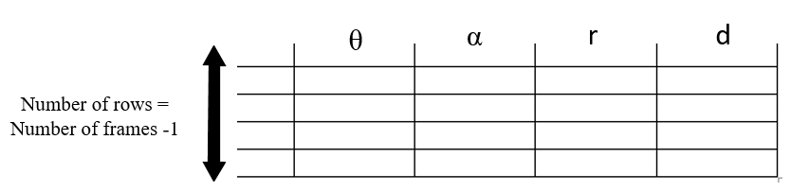

Figure 1: Denavit-Hartenberg parameter table

The following is the definition of the four parameters:

1. θ (joint angle)

Represents how many rotations occur in Zn-1 to make the Xn-1 axis parallel to the Xn axis. Theta rotation must also be included.

1. α (link twist)

It is how many rotations occur in Xn to make the Zn-1 axis parallel to the Zn axis. Theta rotation does not need to be included. Even though Xn is the rotating axis, what seems to be rotating is the n-1 axis.

1. r (link length)

Is the distance between the center point of the n-1 axis and the n axis along the Xn axis.

1. d (link offset)

It is the distance between the centers of the n-1 and n axes along the Zn-1 axis.

3. Fill in the DH Parameters that have been obtained into the transformation matrix with the rules as shown in Figure 2.

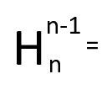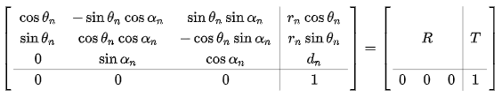

Figure 2: Format for filling in DH parameters on the transformation matrix

The transformation matrix contains elements of rotation and position. To find out the rotation and position of the end-effector with respect to the base frame, it can be searched as shown in Figure 3.

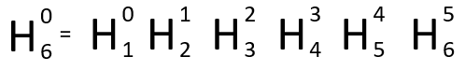

Figure 3: Multiply Dot Product To Generate H0-6

**3 Result**

By following the 4 Denavit-Hartenberg Rules, the kinematics diagram of this 6 DOF robotic arm is described in Figure 4.

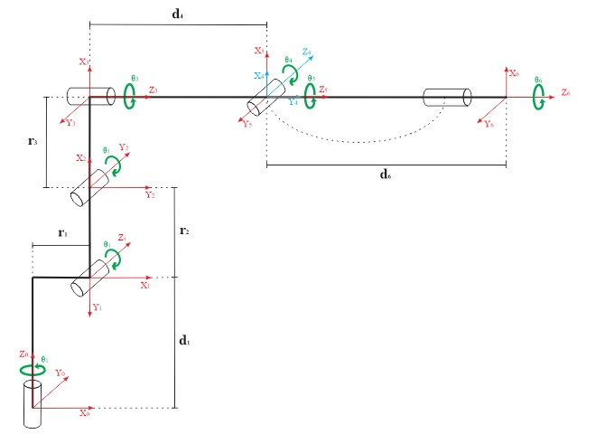

Figure 4: Kinematics Diagram

Robot arm length data:

1. r1 with a length of 47 mm
2. r2 with a length of 110 mm
3. r3 with a length of 26 mm
4. d1 with a length of 133 mm
5. d4 with a length of 117.5 mm
6. d6 with a length of 28 mm

Robot joint angle data:

1. θ1, with limitation: 90o ≤ θ1 ≤ -90o
2. θ2, with limitation: -45o ≤ θ2 ≤ 90o
3. θ3, with limitation: -90o ≤ θ3 ≤ 45o
4. θ4, with limitation: -180 o ≤ θ4 ≤ 180o
5. θ5, with limitation: -90 o ≤ θ5 ≤ 90 o
6. θ6, with limitations: -infinite ≤ θ6 ≤ infinite

DH parameters namely θ, α, r, and d have been obtained with the results listed in Table 1.

Table 1: The obtained DH parameters

|  |  |  |  |  |
| --- | --- | --- | --- | --- |
|  | θ | α | r | d |
| 1 | θ1 | -90 o | r1 | d1 |
| 2 | -90o+ θ2 | 0 o | r2 | 0 |
| 3 | θ3 | -90 o | r3 | 0 |
| 4 | θ4 | 90 o | 0 | d4 |
| 5 | θ5 | -90 o | 0 | 0 |
| 6 | θ6 | 0 o | 0 | d6 |

Then the DH parameters that have been found are entered into the transformation matrix according to the format. The following is the transformation matrix of each successive joint:

H0-1 =

$$\begin{matrix}cos⁡(θ1) & -sin⁡(θ1).cos⁡(-90°) & sin⁡(θ1).sin⁡(-90°) & r1.cos⁡(θ1) \\ sin⁡(θ1) & cos⁡(θ1).cos⁡(-90°) & -cos⁡(θ1).sin⁡(-90°) & r1.sin⁡(θ1) \\ 0 & sin⁡(-90°) & cos(-90°) & d1 \\ 0 & 0 & 0 & 1\end{matrix}$$

H1-2 =

$$\begin{matrix}cos⁡(-90°+θ2) & -sin⁡(-90°+θ2).cos⁡(0°) & sin⁡(-90°+θ2).sin⁡(0°) & r2.cos⁡(-90°+θ2) \\ sin⁡(-90°+θ2) & cos⁡(-90°+θ2).cos⁡(0°) & -cos⁡(-90°+θ2).sin⁡(0°) & r2.sin⁡(-90°+θ2) \\ 0 & sin⁡(0°) & cos⁡(0°) & 0 \\ 0 & 0 & 0 & 1\end{matrix}$$

H2-3 =

$$\begin{matrix}cos⁡(θ3) & -sin⁡(θ3).cos⁡(-90°) & sin⁡(θ3).sin⁡(-90°) & r3.cos⁡(θ3) \\ sin⁡(θ3) & cos⁡(θ3).cos⁡(-90°) & -cos⁡(θ3).sin⁡(-90°) & r3.sin(θ3) \\ 0 & sin⁡(-90°) & cos⁡(-90°) & 0 \\ 0 & 0 & 0 & 1\end{matrix}$$

H3-4 =

$$\begin{matrix}cos⁡(θ4) & -sin⁡(θ4).cos⁡(90°) & sin⁡(θ4).sin⁡(90°) & 0.cos⁡(θ4) \\ sin⁡(θ4) & cos⁡(θ4).cos⁡(90°) & -cos⁡(θ4).sin⁡(90°) & 0.sin⁡(θ4) \\ 0 & sin⁡(90°) & cos⁡(90°) & d4 \\ 0 & 0 & 0 & 1\end{matrix}$$

H4-5 =

$$\begin{matrix}cos⁡(θ5) & -sin⁡(θ5).cos⁡(-90°) & sin⁡(θ5).sin⁡(-90°) & 0.cos⁡(θ5) \\ sin⁡(θ5) & cos⁡(θ5).cos⁡(-90°) & -cos⁡(θ5).sin⁡(-90°) & 0.sin⁡(θ5) \\ 0 & sin⁡(-90°) & cos⁡(-90°) & 0 \\ 0 & 0 & 0 & 1\end{matrix}$$

H5-6 =

$$\begin{matrix}cos⁡(θ6) & -sin⁡(θ6).cos⁡(0°) & sin⁡(θ6).sin⁡(0°) & 0.cos⁡(θ6) \\ sin⁡(θ6) & cos⁡(θ6).cos⁡(0°) & -cos⁡(θ6).sin⁡(0°) & 0.sin⁡(θ6) \\ 0 & sin⁡(0°) & cos⁡(0°) & d6 \\ 0 & 0 & 0 & 1\end{matrix}$$

The value of θ1 – θ6 is the degree input value that will be given by the master controller. Each joint of the manipulator or DOF (Degree of Freedom) is driven by a sensor located on the master arm [2]. An overview of the created master controller is shown in Figure 5.

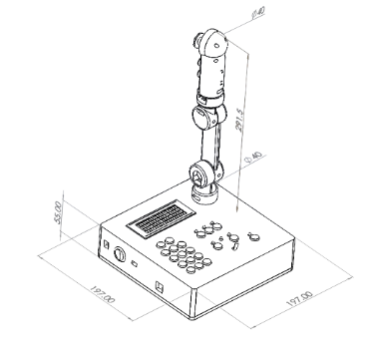

Figure 5: Master Controller

To obtain the end-effector transformation matrix for the base frame, H0-6 needs to be searched using the dot product method as described in Figure 3

Testing the performance of the robot arm position is done by entering the degree value θ1-θ6 into the system. The robot arm will move to a certain position at the same time the system will calculate the value of the end-effector position relative to the base frame. The test results can be seen in Table 2 with a data sample of 20 experiments carried out.

Tabel 2: End-Effector positioning Test

|  |  |  |  |  |  |  |  |  |  |  |  |  |  |  |  |
| --- | --- | --- | --- | --- | --- | --- | --- | --- | --- | --- | --- | --- | --- | --- | --- |
| No | Sudut Masukkan | | | | | | Posisi Perhitungan | | | Posisi Aktual | | | *Error* (%) | | |
| **θ1** | **θ2** | **θ3** | **θ4** | **θ5** | **θ6** | **X** | **Y** | **Z** | **X** | **Y** | **Z** | **X** | **Y** | **Z** |
| 1 | 0 | 0 | 0 | 0 | 0 | 0 | 19,25 | 0 | 26,9 | 19,2 | 0 | 26,5 | 0,26 | 0,00 | 1,51 |
| 2 | 90 | 0 | 0 | 0 | 0 | 0 | 0 | -19,25 | 26,9 | 0 | -19,6 | 26,4 | 0,00 | 1,79 | 1,89 |
| 3 | -90 | 0 | 0 | 0 | 0 | 0 | 0 | 19,25 | 26,9 | 0 | 19,8 | 26,5 | 0,00 | 2,78 | 1,51 |
| 4 | 0 | 80 | 0 | 0 | 0 | 0 | 20,61 | 0 | 1,33 | 21,6 | 0 | 1,3 | 4,76 | 0,00 | 2,31 |
| 5 | 90 | 80 | 0 | 0 | 0 | 0 | 0 | 20,61 | 1,33 | 0 | 21 | 1 | 0,00 | 1,81 | 33,00 |
| 6 | 0 | 0 | -90 | 0 | 0 | 0 | 2,1 | 0 | 38,85 | 2,4 | 0 | 39,2 | 14,29 | 0,00 | 0,89 |
| 7 | -90 | 80 | -90 | 0 | 0 | 0 | 0 | -29,41 | 20,02 | 0 | -31 | 19,4 | 0,00 | 5,13 | 3,20 |
| 8 | 0 | -30 | 0 | 0 | 0 | 0 | 10,5 | 0 | 32,352 | 10,1 | 0 | 32,3 | 3,81 | 0,00 | 0,16 |
| 9 | 0 | 45 | -45 | 0 | 0 | 0 | 27,02 | 0 | 23,678 | 26,5 | 0 | 23,3 | 1,95 | 0,00 | 1,62 |
| 10 | 0 | 0 | 45 | 0 | 0 | 0 | 16,82 | 0 | 15,85 | 16,4 | 0 | 15,5 | 2,50 | 0,00 | 2,26 |
| 11 | 0 | 45 | -30 | 90 | 0 | 0 | 27,2 | 0 | 19,823 | 26,7 | 0 | 19,8 | 1,84 | 0,00 | 0,12 |
| 12 | 0 | 45 | -30 | 0 | 90 | 0 | 23,77 | 0 | 17,843 | 23,5 | 0 | 17,5 | 1,16 | 0,00 | 1,96 |
| 13 | 0 | 45 | -30 | 0 | -90 | 0 | 25,22 | 0 | 23,253 | 24,6 | 0 | 23,7 | 2,48 | 0,00 | 1,89 |
| 14 | 0 | 45 | -30 | 90 | 90 | 0 | 24,5 | 2,8 | 20,54 | 24,2 | 2,8 | 20,3 | 1,22 | 0,00 | 1,18 |
| 15 | 0 | 45 | -30 | -90 | 90 | 0 | 24,5 | -2,8 | 20,54 | 24,7 | -2,8 | 20,3 | 0,82 | 0,00 | 1,18 |
| 16 | 0 | 45 | -30 | 0 | 0 | 90 | 27,2 | 0 | 19,823 | 26,5 | 0 | 19,4 | 2,59 | 0,00 | 2,18 |
| 17 | 0 | 45 | -30 | 90 | 90 | 90 | 24,5 | 2,8 | 20,54 | 24,2 | 2,8 | 20,3 | 1,22 | 0,00 | 1,18 |
| 18 | 90 | 45 | -30 | 90 | 90 | 90 | -2,8 | 24,5 | 20,54 | -2,8 | 24,7 | 19,8 | 0,00 | 0,81 | 3,74 |
| 19 | -90 | 45 | -30 | 90 | 90 | 90 | 2,8 | -24,5 | 20,54 | 2,8 | -25,1 | 20 | 0,00 | 2,39 | 2,70 |
| 20 | -90 | 45 | -30 | -90 | -90 | -90 | 2,8 | -24,5 | 20,54 | 2,8 | -25,1 | 20 | 0,00 | 2,39 | 2,70 |
| Rata-Rata : | | | | | | | | | | | | | **1,94** | **0,85** | **3,36** |

Some documentation of the robot and the results of position calculations can be seen in Figure 6, Figure 7, and Figure 8.

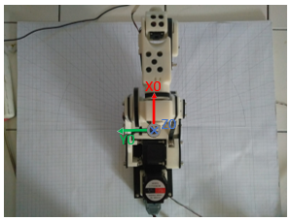 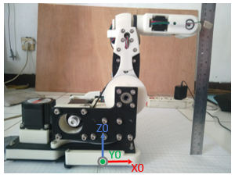

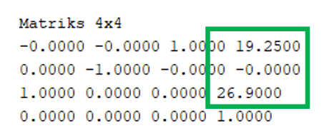

Figure 6. 1st Sample Position Test

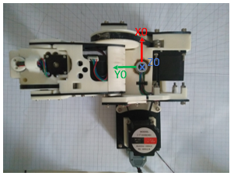 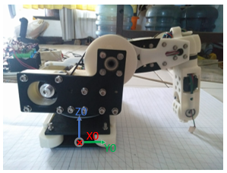

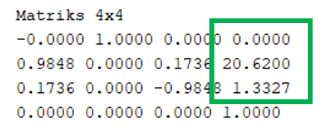

Figure 7. 5th Sample Position Test

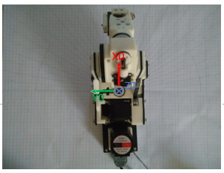 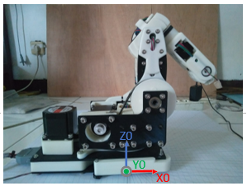

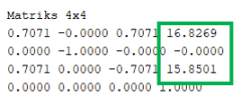

Figure 8. 10th Sample Position Test

**4 Conclusions**

The conclusions of this study refer to several formulations of the problems that have been achieved.

1. By using the Denavit-Hartenberg Method, the forward kinematics calculation for moving the 6 DOF manipulator can be simplified so that the position and rotation values of the end-effector can be known relatively easy. The transformation matrix generated using the DH method is exactly the same as the calculation generated by the manual approach using the homogeneous transformation matrix.
2. The Robot Arm can determine the position of
3. the end-effector against the base frame. The position error on the X axis is 1.94%, on the Y axis is 0.85%, and on the Z axis is 3.36%. The magnitude of this error may be due to factors from the mechanics of the robot arm or measurement inaccuracy, etc.

**References**

1. Daniel. C.S, “Perancangan Jaringan Saraf Tiruan Untuk Menyelesaikan Kinematika Balik Manipulator Robot Denso 6-DOF”. Tugas Akhir, Institut Teknologi Sepuluh November, 2018.
2. Robert D. Christ dan Robert L. Wernli Sr. *The ROV Manual (A User Guide for Remotely Operated Vehicle Second Edition*). Amerika: Elsevier Ltd. 2014.
3. Serdar Kucuk and Zafer Bingul (2006). Robot Kinematics: Forward and Inverse Kinematics, Industrial Robotics: Theory, Modelling and Control, Sam Cubero (Ed.), ISBN: 3-86611-285-8, InTech,
4. Agus B.D, Lina, “Penerapan Metode *Denavit-Hartenberg* Pada Perhitungan *Inverse Kinematics* Gerakan Lengan Robot”, *Jurnal Muara Sains Teknologi, Kedokteran, dan Ilmu Kesehatam Vol.1, No.1, April 2017: hlm 287-292.*
5. J.Denavit, R.S.Hartenberg, A kinematic notation for lower-pair mechanisms based on matrices, Transactions ASME Journal of Applied Mechanics, 1955
6. Myszka, David H., 2012. Machines and mechanism: applied kinematic analysis, 4thed., Prentice Hall, New York.

1.  https://orcid.org/0000-0000-0000-0000
2.  https://orcid.org/0000-0000-0000-0000
3.  https://orcid.org/0000-0000-0000-0000